AI Assignment-08

Jeetu Mehra
U24AI032

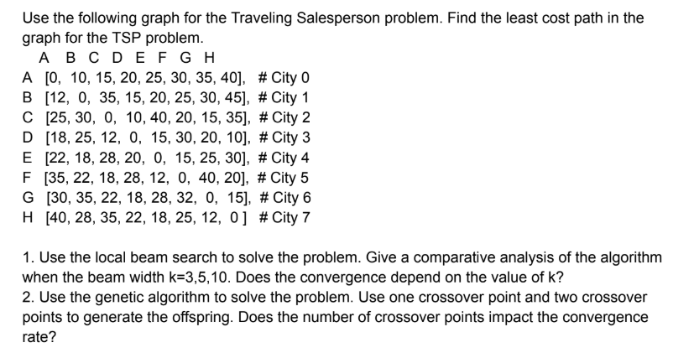Code:
#include <bits/stdc++.h>
using namespace std;

const int N = 8;

int costMatrix[N][N] = {
{0,10,15,20,25,30,35,40},
{12,0,35,15,20,25,30,45},
{25,30,0,10,40,20,15,35},
{18,25,12,0,15,30,20,10},
{22,18,28,20,0,15,25,30},
{35,22,18,28,12,0,40,20},
{30,35,22,18,28,32,0,15},
{40,28,35,22,18,25,12,0}
};

vector<string> cities = {"A","B","C","D","E","F","G","H"};

int calculateCost(vector<int> &tour) {
int total = 0;
for(int i = 0; i < N-1; i++)
total += costMatrix[tour[i]][tour[i+1]];
total += costMatrix[tour[N-1]][tour[0]];
return total;
}

void printTour(vector<int> &tour) {
for(int i : tour)
cout << cities[i] << " ";
cout << cities[tour[0]];
cout << endl;
}

vector<int> localBeamSearch(int k, int maxIterations = 500) {

vector<vector<int>> beam;

// Generate k random initial tours
for(int i = 0; i < k; i++) {
vector<int> tour(N);
iota(tour.begin(), tour.end(), 0);
random_shuffle(tour.begin(), tour.end());
beam.push_back(tour);
}

for(int iter = 0; iter < maxIterations; iter++) {

vector<vector<int>> neighbors;

for(auto &state : beam) {
for(int i = 1; i < N; i++) {
for(int j = i+1; j < N; j++) {
vector<int> temp = state;
swap(temp[i], temp[j]);
neighbors.push_back(temp);
}
}
}

sort(neighbors.begin(), neighbors.end(),
[](vector<int> &a, vector<int> &b) {
return calculateCost(a) < calculateCost(b);
});

beam.clear();
for(int i = 0; i < k && i < neighbors.size(); i++)
beam.push_back(neighbors[i]);
}

return beam[0];
}

int main() {

srand(time(0));

cout << "===== LOCAL BEAM SEARCH =====\n\n";

for(int k : {3,5,10}) {
vector<int> result = localBeamSearch(k);
cout << "Beam Width k = " << k << endl;
cout << "Best Tour: ";
printTour(result);
cout << "Cost: " << calculateCost(result) << "\n\n";
}

return 0;
}

Question 2 : Use the genetic algorithm to solve the problem. Use one crossover point and two crossover
points to generate the offspring. Does the number of crossover points impact the convergence
rate?

Code:
#include <bits/stdc++.h>
using namespace std;

const int N = 8;

int costMatrix[N][N] = {
{0,10,15,20,25,30,35,40},
{12,0,35,15,20,25,30,45},
{25,30,0,10,40,20,15,35},
{18,25,12,0,15,30,20,10},
{22,18,28,20,0,15,25,30},
{35,22,18,28,12,0,40,20},
{30,35,22,18,28,32,0,15},
{40,28,35,22,18,25,12,0}
};

vector<string> cities = {"A","B","C","D","E","F","G","H"};

int calculateCost(vector<int> &tour) {
int total = 0;
for(int i = 0; i < N-1; i++)
total += costMatrix[tour[i]][tour[i+1]];
total += costMatrix[tour[N-1]][tour[0]];
return total;
}

void printTour(vector<int> &tour) {
for(int i : tour)
cout << cities[i] << " ";
cout << cities[tour[0]];
cout << endl;
}

// -------- Single Point Crossover --------
vector<int> crossoverOnePoint(vector<int> &p1, vector<int> &p2) {

int point = rand() % N;
vector<int> child(N, -1);

for(int i = 0; i < point; i++)
child[i] = p1[i];

int index = point;
for(int i = 0; i < N; i++) {
if(find(child.begin(), child.end(), p2[i]) == child.end())
child[index++] = p2[i];
}

return child;
}

// -------- Two Point Crossover --------
vector<int> crossoverTwoPoint(vector<int> &p1, vector<int> &p2) {

int p1_idx = rand() % N;
int p2_idx = rand() % N;
if(p1_idx > p2_idx) swap(p1_idx, p2_idx);

vector<int> child(N, -1);

for(int i = p1_idx; i <= p2_idx; i++)
child[i] = p1[i];

int index = 0;
for(int i = 0; i < N; i++) {
if(find(child.begin(), child.end(), p2[i]) == child.end()) {
while(child[index] != -1) index++;
child[index] = p2[i];
}
}

return child;
}

vector<int> geneticAlgorithm(bool twoPoint = false,
int populationSize = 50,
int generations = 500) {

vector<vector<int>> population;

// Initial Population
for(int i = 0; i < populationSize; i++) {
vector<int> tour(N);
iota(tour.begin(), tour.end(), 0);
random_shuffle(tour.begin(), tour.end());
population.push_back(tour);
}

for(int gen = 0; gen < generations; gen++) {

sort(population.begin(), population.end(),
[](vector<int> &a, vector<int> &b) {
return calculateCost(a) < calculateCost(b);
});

vector<vector<int>> newPop;

// Elitism
newPop.push_back(population[0]);
newPop.push_back(population[1]);

while(newPop.size() < populationSize) {

vector<int> parent1 = population[rand()%10];
vector<int> parent2 = population[rand()%10];

vector<int> child;

if(twoPoint)
child = crossoverTwoPoint(parent1, parent2);
else
child = crossoverOnePoint(parent1, parent2);

// Mutation
if(rand()%100 < 10) {
int i = rand()%N;
int j = rand()%N;
swap(child[i], child[j]);
}

newPop.push_back(child);
}

population = newPop;
}

sort(population.begin(), population.end(),
[](vector<int> &a, vector<int> &b) {
return calculateCost(a) < calculateCost(b);
});

return population[0];
}

int main() {

srand(time(0));

cout << "===== GENETIC ALGORITHM =====\n\n";

vector<int> result1 = geneticAlgorithm(false);
cout << "Single Point Crossover:\n";
cout << "Best Tour: ";
printTour(result1);
cout << "Cost: " << calculateCost(result1) << "\n\n";

vector<int> result2 = geneticAlgorithm(true);
cout << "Two Point Crossover:\n";
cout << "Best Tour: ";
printTour(result2);
cout << "Cost: " << calculateCost(result2) << "\n";

return 0;
}

